Configuring Run Setting

The purpose of this user guide is to show engineers how to change Tests context using run settings files.

Table of Contents

Configuring Run Setting 1

Table of Contents 1

Instructions 2

Introduction 2

Steps 2

Instructions

# Introduction

Unit tests in Visual Studio can be configured by using a **.runsettings** file. Run settings files can be used to configure tests that are run from the IDE.

# Steps

1. 1. In the IDE, in the *Test Explorer* window ***Select the down arrow next to the gear icon > Configure Run Settings > Select Solution Wide runsettings File***, and then select the .runsettings file. A screenshot of a computer

   Description automatically generated with medium confidence

For example, select *rating.runsettings*

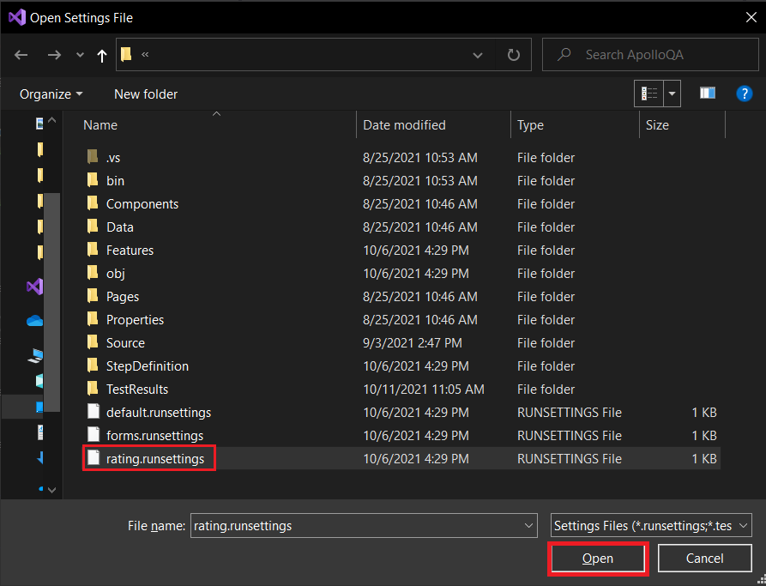

1. Build the solution (*Ctrl + Shift + B*) to apply changes in *Test Explorer*
2. Go to *This PC*, right click *Properties*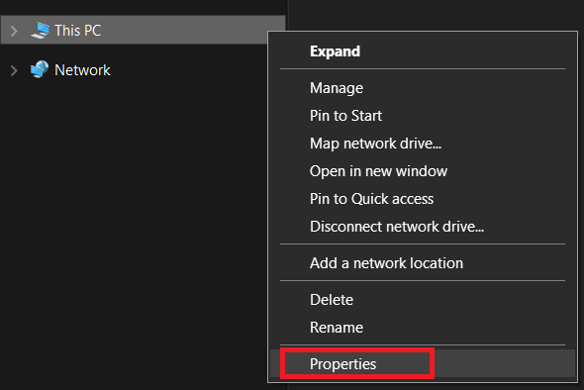
3. Click *Advance system settings* and then *Environment variables…*  
   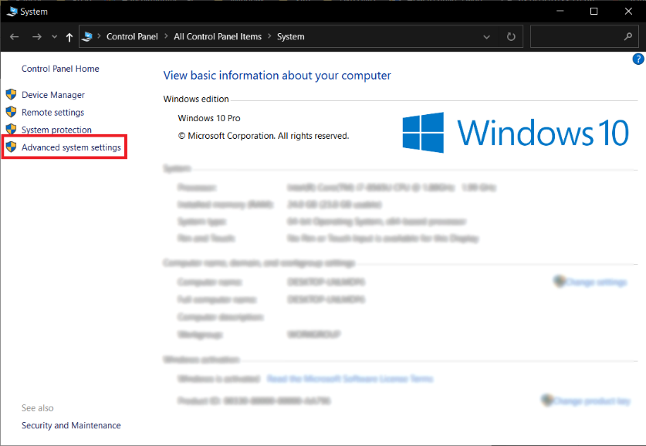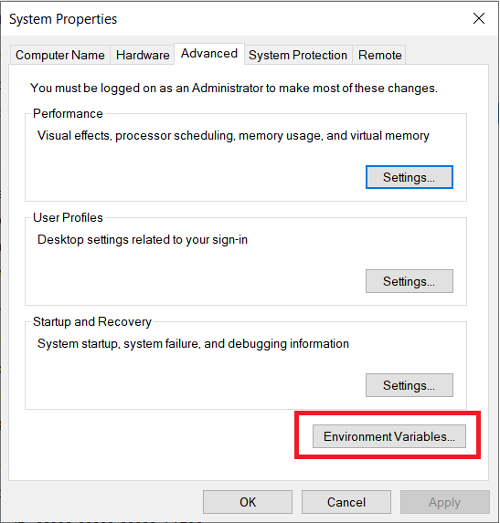
4. In the *User variables* section click the *New…* button to add a new User Variable with the following values:  
   *Variable name*: ENVIRONMENT_FILE  
   *Variable value*: qa.env.json  
   Click Ok to save changes  
     
   Graphical user interface

   Description automatically generated

This environment variable reference the *qa.env.json* file in the project, where you can change values like the url *HOST* url for the QA environment

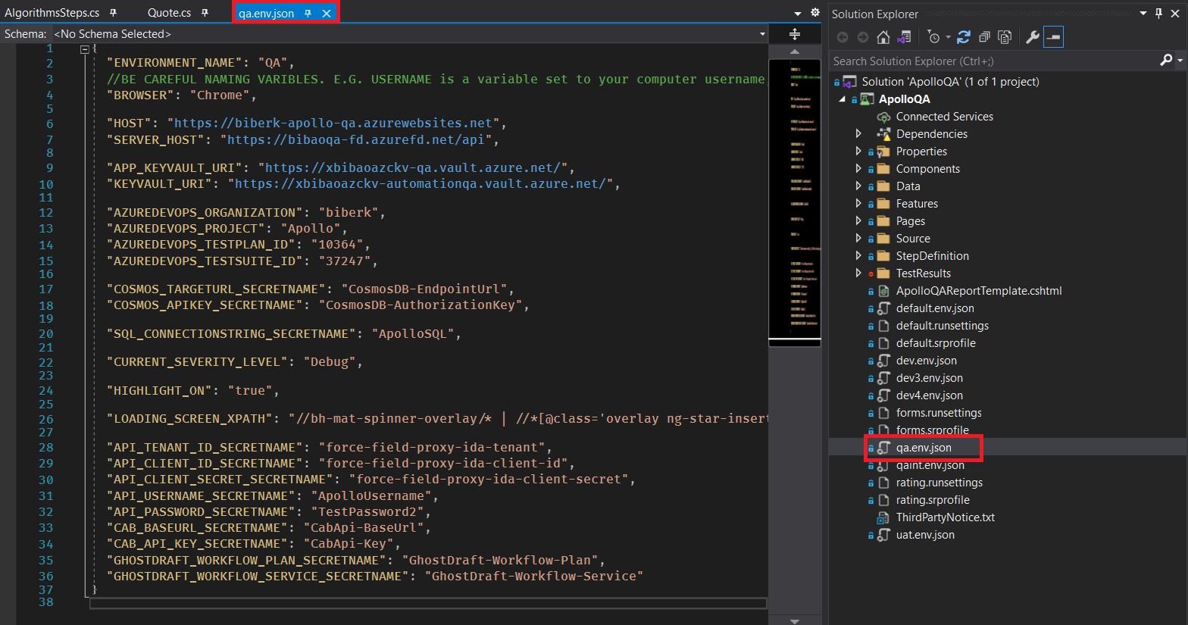

1. If you have Visual Studio open, close it and open it again